## **Candidate Name**: SUJIT KUMAR SWAIN

## **Technical Writing Test**

## Please attempt the following exercises to help us evaluate your editing and writing skills.

# Grammar & Language

The following sentences are verbose and some have errors too. Shorten and correct these sentences without losing the meaning or any important detail. (1 Mark each)

1. He was as tall as a six foot three inch tree.  
   **He was as tall as a six-foot-three-inch tree.**
2. I answered all question accept the ones I didn’t knew.  
   **I answered all the questions except the ones I did not know.**
3. While going to work, a dog bit me.  
   **When I was going to work, a dog bit me.**

1. The clerk was proficient in brilliant verbal/written communications, persuasive presentations, and meticulous research.  
   **The clerk was proficient in brilliant communication, persuasive presentation, and meticulous research.**
2. Even after great attempts, I could not able to solve the puzzles.  
   **I could not solve the puzzles, even after great attempts.**
3. A possible cause is likely the apparent tendency of a certain number of users with no technical knowledge to develop aversion to deep isntalls.  
   **Maybe a few users without technical knowledge develop an aversion to deep installs.**
4. Working with the ground staff for so many years, Jacob gathered a great deal of technical skills.  
   **Jacob gathered a lot of technical skills working with the ground staff for many years.**
5. Once upon a time, in the recent future, the world was inhabited by very large spiders.  
   **Once upon a time, massive spiders made the world inhabited.**
6. Not only did she wear a frilly purple dress, but she also wore a floppy yellow hat that made her impossible to miss in a crowd.  
   **She wore a frilly purple dress and a floppy yellow hat that made her recognizable in the crowd.**
7. In the event that this motor is for some reason shut down, be sure to know that the air circulation will be most likely stopped.  
   **If this motor shuts down in the even, the air circulation may mostly stop.**

# Editing

**Exercise I: Edit the following texts as requested, while ensuring that these comply with technical writing best practices:  
(2 Marks each)**

1. Background: In Hevo, a Pipeline extracts data from one system and loads it to another. A button, **Run Now**,isprovided in the UI,next to eachPipeline, to allow users to run it manually outside of the configured frequency.   
     
   Edit the following tooltip text for the button to make it correct and relevant:

*The request to run the Activation has been accepted. It might take a few seconds before it starts ingesting data.*

Answer: **Run Manually**

1. Edit and restructure the following text to make it coherent and informative  
     
   *In the TEAM MEMBERS page, enter the member’s email id you would want to invite in the Email Address input box and click Invite. You will be able to see the email id added to the member’s list in the TEAM MEMBERS page.*

Answer: Enter the mail ID of the new member on the **TEAM MEMBERS** page and click **Invite**. The new mail id appears in the **Members** list.

**Exercise II: Read the information below and provide the answer text.**

Apple Search Ads is one of the Sources from which Hevo can fetch data and load to a customer’s data warehouse. Apple Search Ads currently has an issue (bug), where-in new API Certificates are not being created for the time being. These certificates include the PEM and Key files, which are needed to configure new Pipelines, similar to how user+password works.

If users have any previously created certificates that have not expired, they may use them. But other users who cannot create new certificates cannot configure ePipelines for the time being.

Write this information in the form of an alert that can be displayed to the user when they create a Pipeline with Apple Search Ads.

**Apple Search Ads** as a source has an issue with the certificate for configuring new pipelines. If you already have a valid certificate, please continue with that.

# Writing

Document the procedure for signing up for a free trial at [www.hevodata.com](http://www.hevodata.com/) and getting set up for creating your first Pipeline. Mention any assumptions that you make. (25 marks)

Feel free to include suggestions for improving the user interface. Marks are awarded for user orientation, information structure, clarity of content, grammar, and technical writing principles used.

# **How to Sign Up for Hevo?**

Hevo is an intuitive and feature-rich product that helps you in data replication and analysis. It addresses all foreseeable business scenarios. To sign up for Hevo:

1. Go to [www.hevodata.com](http://www.hevodata.com/).
2. Type your work mail ID.
3. Click **Try Hevo for free**. The **Create Your Free Account** page opens.  
   **Note**: Hevo does not accept personal mail IDs.
4. Your work email ID appears on the page. You can sign up by tying your credentials, or clicking **SIGNUP WITH GOOGLE FOR WORK** (If you have Google federated identity for work). To sign up with credentials:
   1. Type your full name and a minimum of an eight-character password.
   2. Click **START YOUR FREE TRIAL**. The **Set up your Profile** page appears.
5. Select your organization size from the **Employee Range** drop-down.
6. Select your role. If it is not available in the drop-down list, select **Other**.
7. Type the role and phone number.  
   **Note**: Chat support is also available. Check the bottom-right corner of your display.
8. Click **NEXT**. The **Log in to your Account** page appears.

# **How to Log in to Hevo**

After signing up for Hevo, you can log in to your Hevo account.

1. Go to [www.hevodata.com](http://www.hevodata.com/) and click **Log in**. The **Log in to your Account** page appears.
2. Type your registered mail ID or verify if it appears on the page.
3. Click **CONTINUE**. The **Log in to Hevo** page appears.
4. Type your password and click **LOG IN**. Your Hevo Dashboard appears.

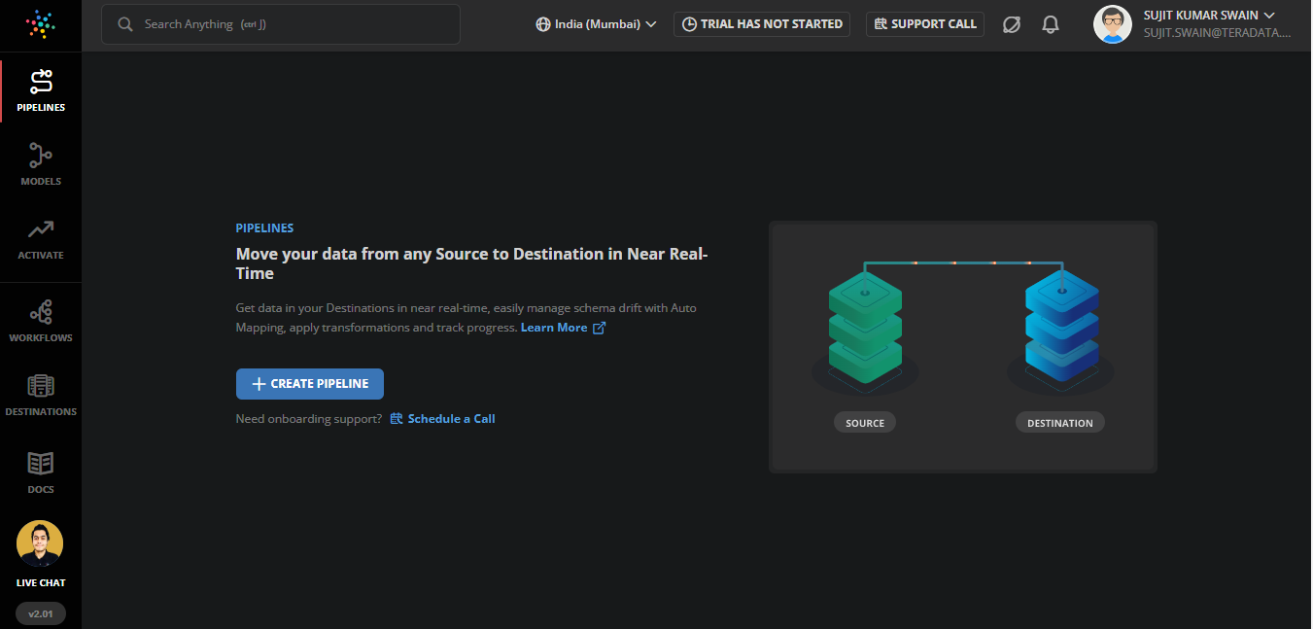

# **Hevo Dashboard**

You can use the Hevo dashboard to:

* Create pipelines
* Create models
* Create activations
* Create workflows
* Add destinations
* Access Hevo documents
* Start live chats and support calls.

# **Suggestions on UI**

* Follow leads-caps for page titles. Prepositions and articles are exceptions.
* **SIGNUP** WITH GOOGLE FOR WORK > **SIGN UP** WITH GOOGLE FOR WORK
* Button text: **Try Hevo for free** > **TRY HEVO FOR FREE**. To maintain consistency with the sign-up page buttons.
* Page title: **Login in to your Account > Login to Your Account**
* Page title: **Login in to Hevo > Login to Hevo**
* Pressing **Ctrl+K** on Hevo dashboard is not taking the user to the **WORKFLOWS** page (Browser: Microsoft Edge).